Release Note

Auto Archive Sales Order on release

# 1 Basic Details

|  |  |
| --- | --- |
| Customer |  |
| Customer Name | N/A |
| Customer PM  (Where appropriate) | N/A |

|  |  |
| --- | --- |
| Release Control |  |
| Reference No. |  |
| Author | Marcus Ambra |
| Release | 2004-01R |
| Risk Level | High |
| Release Date | 15/04/2020 |
| Release Media | FOB |
| Release Reason | Incident |
| Database Version | Dynamics NAV 2018 (11.0.24742) |
| Package Name | NA |
| Delivery Method | NA |
| Customer Approval  (Delivery) | NA |

|  |  |
| --- | --- |
| Work Detail |  |
| Project Name | Auto Archive Sales Order on Release |
| Project Manager | NA |
| Project Phase | Project |
| Person (Developer/Consultant) | Marcus Ambra |
| Functional Area | Sales Processing |
| Reviewer/Approver (Peer/Senior) |  |
| Design Reference | NA |
| Development Release note no. | NA |

# 2 Overview

I have extended the standard auto archive functionality for sales order, which will archive the lateast version of the saler quote/order once the doucment is released.

This is useful for companies which want to track all modifications performed in the order before the document was released.

Originally the document is only archived when the document is deleted (manually deleted or final posting)

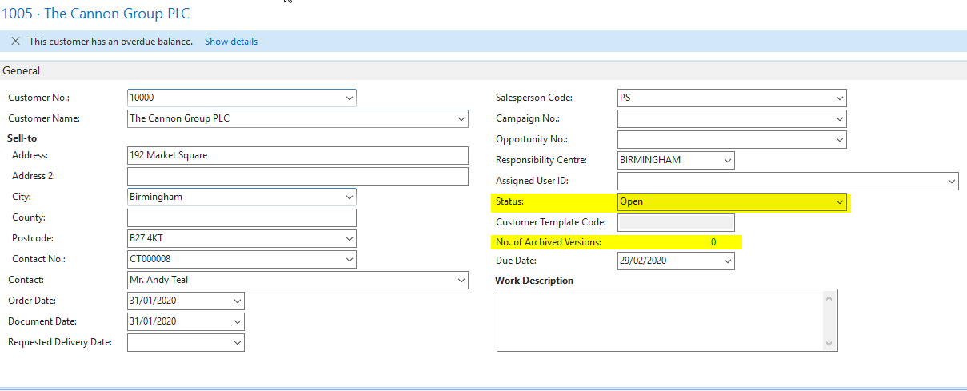

Once the document is released, then the document will be automatically archived.

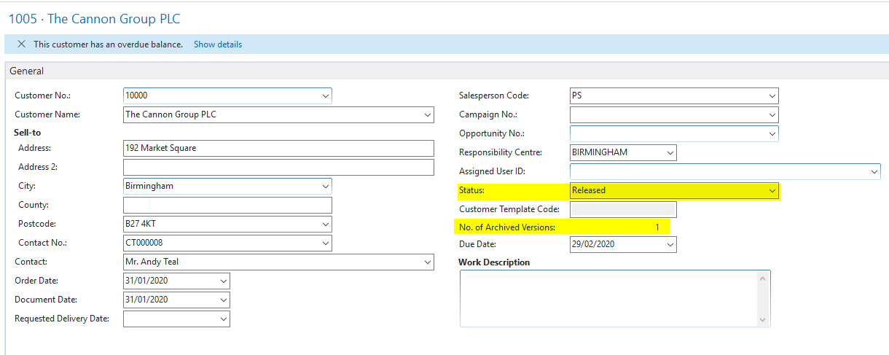

# 3 Technical Details

## 3.1 Summary of Solution Modifications

**Table: 311-Sales & Receivables Setup**

* **Created the new field below:**



**Page: 459-Sales & Receivables Setup**

* **Added the field 50000**

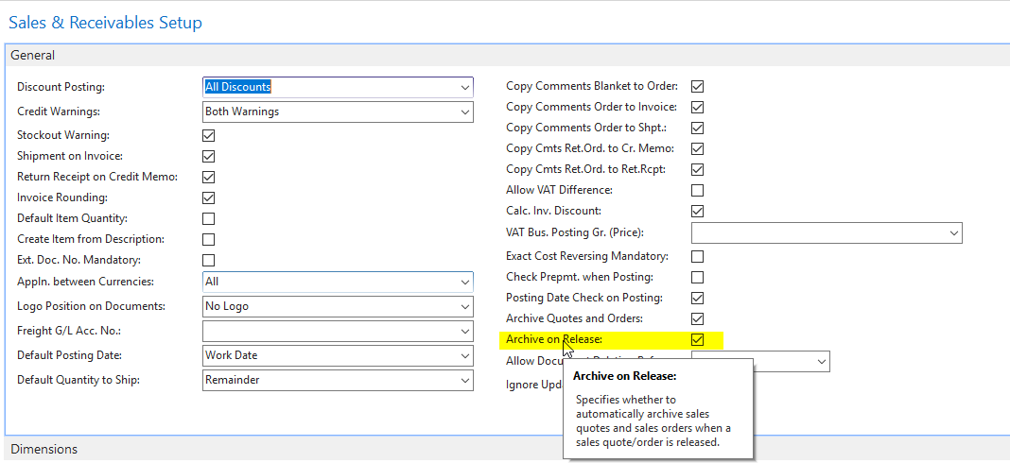

**Codeunit: 414-Release Sales Document**

**Tigger: On Run**

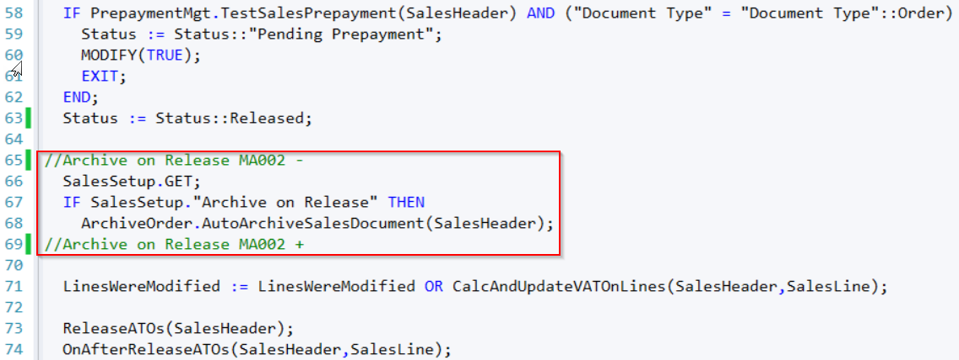

### 3.1.1 Modifications

The following new modifications have been completed and tested:

|  |  |  |  |
| --- | --- | --- | --- |
| Reference | Source | Type | Summary |
|  |  |  |  |

## 3.2 Object Changes

**Important Note**: If there is any discrepancy between the Original Object details and the corresponding Object Details in your database, please do not import them, but inform immediately with details.

### 3.2.1 Object Verification

|  |  |
| --- | --- |
| Source database object changes were developed in |  |
| Date development objects compared to live | 15/04/2020 |

### 3.2.2 Existing

|  |  |  |  |  |  |  |
| --- | --- | --- | --- | --- | --- | --- |
| Object Type (table, form, etc.) | Object ID | Name | Modified | Version | Date | Time |
|  |  |  |  |  |  |  |

### 3.2.3 New

|  |  |  |  |  |  |  |
| --- | --- | --- | --- | --- | --- | --- |
| Object Type (table, form, etc.) | Object ID | Name | Modified | Version | Date | Time |
|  |  |  |  |  |  |  |

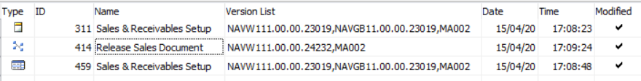

## 4. Post Deployment Testing Steps

Please ensure your testing is proportionate to the level of risk.

### 4.1 To Test Code

### 4.2 To Test Data Fix

Not required

# 5 Quality Assurance

## 5.1 Testing Completed

NA

## 5.2 Code Review / Testing

|  |  |  |
| --- | --- | --- |
|  | Name | Date completed |
| Unit Test completed by | Marcus Ambra | 15/04/2020 |
| Code Review completed by | Marcus Ambra | 15/04/2020 |
| Testing completed by | Marcus Ambra | 15/04/2020 |
| UAT testing completed successfully | Marcus Ambra | 15/04/2020 |

# 6 Sign Off

|  |  |  |  |
| --- | --- | --- | --- |
| Action | Name | Signature | Remarks |
| Released By | Marcus Ambra | Marcus Ambra |  |
| Approved By |  |  |  |

All objects/changes moved in to your live environment by yourself or otherwise, are considered complete and approved. Any further changes required after this stage may be considered a new change request.

Please be aware that objects/changes not moved into your live environment within a reasonable amount of time, upon completed user acceptance testing, may cause conflict with other objects/changes.